

**Mitsubishi 2 Ton Inverter Series HJ71VA**

**Rs. 148,000/-**

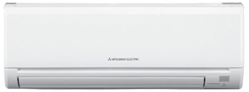

**Product Features**

* easy clean(indoor)
* Intelligent airflow
* Econo Cool
* New LEV Control
* Electronic Metal Housing Box

**Specification**

**Type** Wall Mounted Split AC

**Cooling (Btu/h)** 35000

**Voltage (V)** 220-240

**Power Input (W)** 3500

**EER (Btu/W-h-W/W)** 6.4-2.40